English 10: World Literature
Unit 5: Reading Asian-Pacific Mythology
“Translating” Asian-Pacific Folktales and Legends
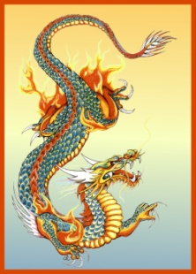
Standards Assessed:
Standard #25
Apply knowledge of language to understand how language functions in different contexts, to make effective choices for meaning or style, and to comprehend more fully when reading or listening.

Utilizing your legend/folktale, “translate” or rewrite it in the following three ways. You may want to divide your legend/folktale into three parts; a beginning, middle, and an end. Remember that the legend/folktale must remain, essentially, the same…The characters, plot, setting, and theme must be the same as the actual version; just the language of the legend/folktale will change.

- “Translate” the beginning of the legend/folktale for children ages 6-8 years old. Be simple and silly. Use examples of children’s books for assistance.

- “Translate” the middle of the legend/folktale as if it was a newspaper article or news report. Pretend the story happened yesterday. Be captivating, factual, and succinct. Use examples of newspaper articles and news reports for assistance.

- “Translate” the ending of the legend/folktale for a college English professor. Pretend the professor respects grand vocabulary and complex sentence structures. Use classic novels as examples for assistance.

