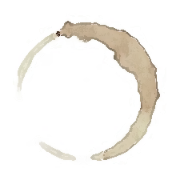 Bridge Builder
Lit
Purpose: To build bridges between the events of the book and other
people, places, or events in school, the community, or your own life;
make connections between what has happened before and what might
happen as the novel continues.

Name: | Book:
Group: | Pages:

Event from Book | Types of Connections | Connection
Text to Self

Text to Text

Text to World
Text to Self

Text to Text

Text to World
Text to Self

Text to Text

Text to World

What has happened previously in the book? | What will happen as the book continues?

