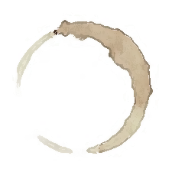 Artist
Lit
Purpose: To create an illustration related to the reading; create a sketch,
cartoon, diagram, flow chart, or other depiction; illustrate a scene, an
idea, a symbol, or a character; write a reflection that explains your
illustration.

Name: | Book:
Group: | Pages:

Reflection:
____________________________________________________________________________________________________________________________________________________________________________________________________________________________________________________________________________________________________________________________________________________________________________________________________________________________________________________________________________________

