Name: ________________________ Date: _____________

What is the Introduction?

Go to chapter 9 of your Speech textbook. Examine what the introduction must include. Answer the following questions.

- Define the following “attention getters”:

  - Asking Questions …

  - Making References …

  - Making a Startling Statement …

  - Giving a Quotation …

  - Telling a Story …

- What is the “link”?

- What is the thesis “statement”?

- What is the “preview statement”?

- Complete #1 in the “Taking Charge” part of the Section 1 Review on page 215. Follow the directions and write an introduction for your friend. This will be a mini speech you will give to the class.

What is the Conclusion?

Go to chapter 9 of your Speech textbook. Examine what the conclusion must include. Answer the following questions.

- What is the summary? What should it include?

- What is the final clincher or final impression?

- Complete #1 in the “Taking Charge” part of the Section 3 Review on page 228. Follow the directions but write just a conclusion for an imaginary speech. This will be a mini speech you will give to the class.

What is the Body?

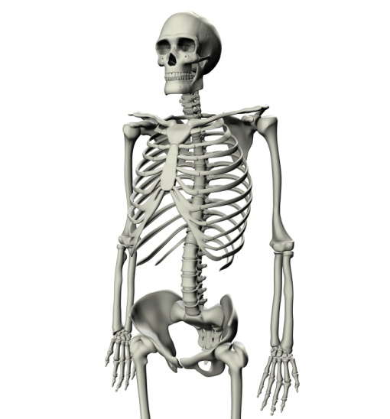

Go to chapter 9 of your Speech textbook. Examine what the body must include. Answer the following questions.

- What is the body of your speech?

- What is an outline?

- What is the purpose statement?

- What are the main headings?

- What are the supporting materials?

- What are the details?

- Define each of the ways you can organize your speech and give an example of what the outline might look like:

  - Chronological

  - Climactic

  - Spatial

  - Cause-effect

  - Problem-solution

- Complete #1 in the “Taking Charge” part of the Section 2 Review on page 225. Write your “outlines” below.

