Humans of Veritas
Class Photo Blog
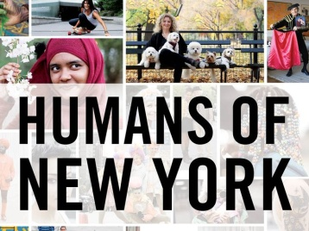

We will create a class photoblog similar to the Facebook and Tumblr photoblog Humans of New York, which features street portraits and interviews collected in New York City.

Here’s how:

- Start taking pictures of the people here at Veritas High School…
  - They can be friends or teachers or strangers!
  - It needs to be a portrait.
  - Interview or talk to them and write down a quote/conversation.
    - Ask random, thought-provoking questions…And then ask them to elaborate more! Don’t switch topics!
  - Choose the most powerful portrait and quote you captured.
    - Sometimes “normal” people and “mundane” quotes can be very moving!
    - You can include a conversation if you want.

- Upload the photo and quote to our class photo blog by meeting with Neman.
  - http://humansofveritas.blogspot.com/
  - The title of your entry, and everybody else’s, will be “Humans of Veritas”
    - You will do several of these entries throughout the year.

- Later, you will write comments on other people’s photoblog entries…

