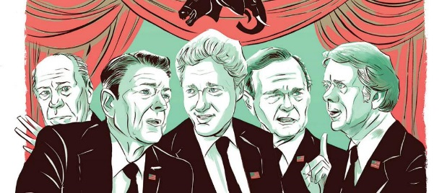
Five Presidents
Critic’s Review
Write an article about the show we’ve seen. Pretend you’re a critic, and you’re analyzing and critiquing the show. Remember to state your opinion, utilizing evidence from the show to support your view. This article should be at least 700 words.

Your article should include the following:

- A summary of the story; its plot, setting, characters, resolution, etc.

- Your opinion of the story.
  - Was the story entertaining? Inspirational? Educational?
  - Include evidence from the story to support your view.

- Your opinion of the acting in the show.
  - Was it believable? Memorable? Emotional? Why or why not?
  - Who was the best actor/actress? Why? Who was the worst? Why?
  - Include evidence from the show to support your view.

- Your opinion of the artistic aspects of the show.
  - What did you think of the costumes and make-up? Explain.
  - What did you think of the set design? Explain.
  - What did you think of the props? Explain.
  - Include evidence from the show to support your view.

- Your opinion of the technical aspects of the show.
  - What did you think of the lighting? Explain.
  - What did you think of the sound? Explain.
  - What did you of the other technical parts? Explain.
  - Include evidence from the show to support your view.

- Your opinion of the entire show as a whole.
  - Would you recommend people to pay and see it? Why or why not?
  - What “letter grade” or how many “stars” or “thumps up” would give it? Explain.
  - Include evidence from the story to support your view.

