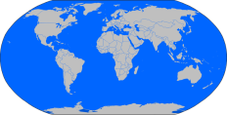Researching and Changing the World

Concluding Paragraph EXAMPLE:

______________________________________________________________________________

The oceans of my heart need protecting. The National Marine Sanctuary Foundation is fighting to protect the beautiful oceans surrounding the island of American Samoa. The small Polynesian island in the South Pacific is a gorgeous, ancient tropical paradise. The problem of pollution is threatening this island’s stunning and powerful nature and culture. Like any crime, we need to stop it. One way to help is by donating money to the National Marine Sanctuary Foundation. With their awesome assistance, we all will be able to enjoy the gorgeous oceans surrounding American Samoa and our world. We’ll all be able to snorkel safely and be with the lively animals and plants and waters. We’ll be able to save this vital ecosystem of earth. We can all help the oceans by aiding the National Marine Sanctuary Foundation. And maybe someday the oceans of MY heart will be of OUR heart.

