English 10: World Literature
Unit 5: Reading Asian-Pacific Mythology
Battle Royale
The Movie and Book
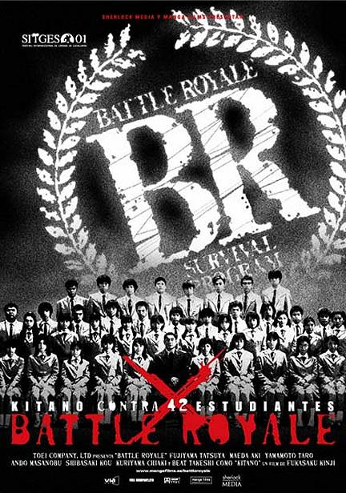
Standards Assessed:
Standard #4
Analyze the representation of a subject or a key scene in two different artistic mediums, including what is emphasized or absent in each treatment.

You will read and watch a key scene from Battle Royale, a Japanese film and book.
- Read chapter 4 of Koushun Takami’s Battle Royale. Complete the “Cast of Characters” sheet. Also, annotate it by utilizing the “Annotating a Text” worksheet.
- Watch the same scene in the film version of Battle Royale. Describe, in at least five sentences, what you observed.

- Complete the following chart in regards to the different and same representations between the book and film.
Differences | Similarities

- What is emphasized in the film version that isn’t in the book version?

  - Explain why you think this is emphasized in the film version.

- What is absent in the film version that was in the book version?

  - Explain why you think this is absent in the film version.

