English 10: World Literature
Unit 5: Reading Asian-Pacific Mythology
Asian-Pacific Folktales and Legends
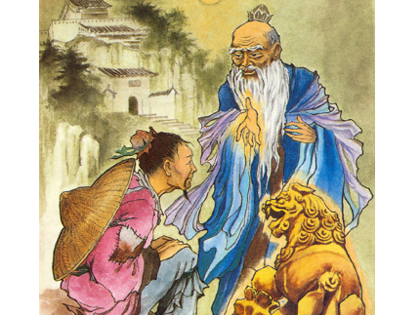
Standards Assessed:
Standard #3:
Analyze how complex characters develop over the course of a text, interact with other characters, and advance the plot or develop the theme.

You will be assigned one of the following:
-Half-Child (Indonesia)
-Shade Selling (Korea)
-Archer Hou Yi and Chang-O (China)
-The Jelly-Fish and the Monkey (Japan)
-The Herdsboy and the Weaving Maid (China)
-Serungal (Malaysia)
-The Dream at Nam Kha (Vietnam)
-Rajah Soliman’s Daughter (Philippines)

Read the legend/folktale and complete the following tasks:

- Who is the main character? Describe their internal and external traits at the beginning.

- How does the main character interact with other characters?

- What is the plot of the story? In other words, what is the major problem or obstacle in the legend/folktale? Did the main character create this problem? Explain why or why not.

- Describe the main character’s internal and external traits in the middle of the legend/folktale.

- Describe the main character’s internal and external traits at the end of the legend/folktale.

- What is the theme of the legend/folktale? Explain how you came to this conclusion. How does the development of the main character show this theme?

